Working with APIs
Rest APIS
Representational state transfer (REST) is one way of providing interoperability between computer systems on the Internet. API stands for Application Programming Interface.
API is nothing but a bridge which connects and makes interaction btw two different applications .
The REST APIs allow us to perform administration tasks in EPM Cloud
- Oracle Planning and Budgeting Cloud
- Oracle Enterprise Planning and Budgeting Cloud
- Financial Close and Consolidation System
- Tax Reporting
- Oracle Account Reconciliation Cloud
- Oracle Profitability and Cost Management Cloud
REST APIs give us another way to create and elaborate the automation process by using different languages. By using REST APIs, we could build custom integration to provide basic and innovative services on top of these EPM Automate commands.
Using REST APIs requires considerable technical & functional expertise. How to use them really depends on the language you choose but in EPM you can use only through groovy.
Using REST API in Groovy business rule is similar to how EPM Automate developed. In fact, EPM Automate is built on top of REST API. With the new Groovy functionality, we can call EPM Automate REST recourses from planning Groovy business rules.
REST API Client
To start using REST API, I highly suggest you using REST client to test your solution first. Then translate that to a Planning Groovy business rule.
Suggested Client :
- Postman
- Insomnia
APIs example: https://url.com/endpoints
APIs do have accessibility which makes them secure when using .
It can username & password.

Some sample basic requests while working with APIs you need to know.
- GET – Retrieve information about the REST API resource
- POST – Create a REST API resource
- PUT – Update a REST API resource
- DELETE – Delete a REST API resource or related component
Below fig shows the requests.
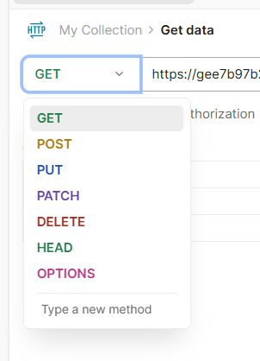

Here is sample connection with REST API:
- Request Method
- API with endpoint
- Click send to get
- Authentication
- Query parameter
- Output area
- Response status
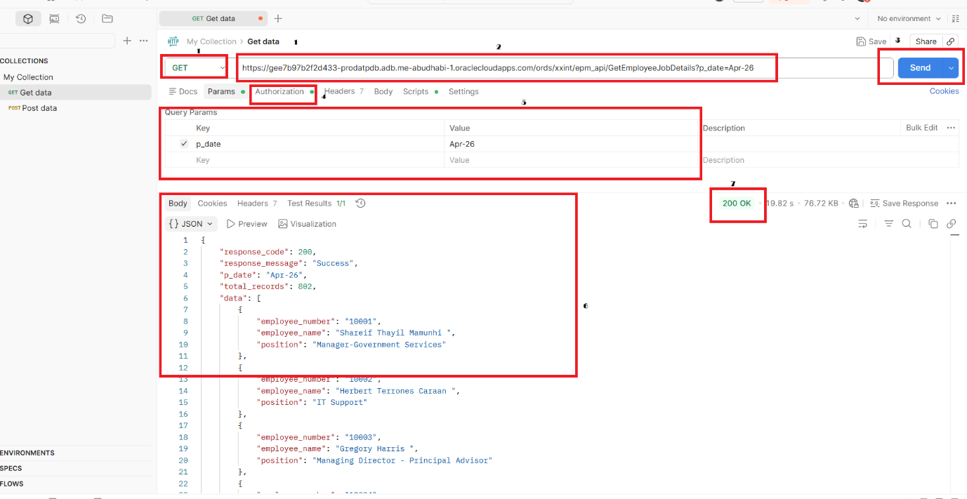

Now you get basic idea of what APIs are and how to use them.
When you want use use any APIs in EPM , you need to refer to them in rules.
Inorder to that you 1st need to create a connect with the API in EPM.
Navigation :
Navigator->Tools -> Connections
Click on create
Select the provider as Other Web Service Provider.
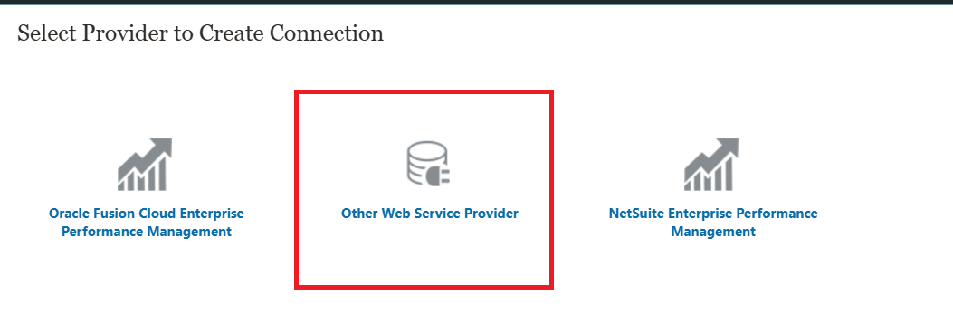
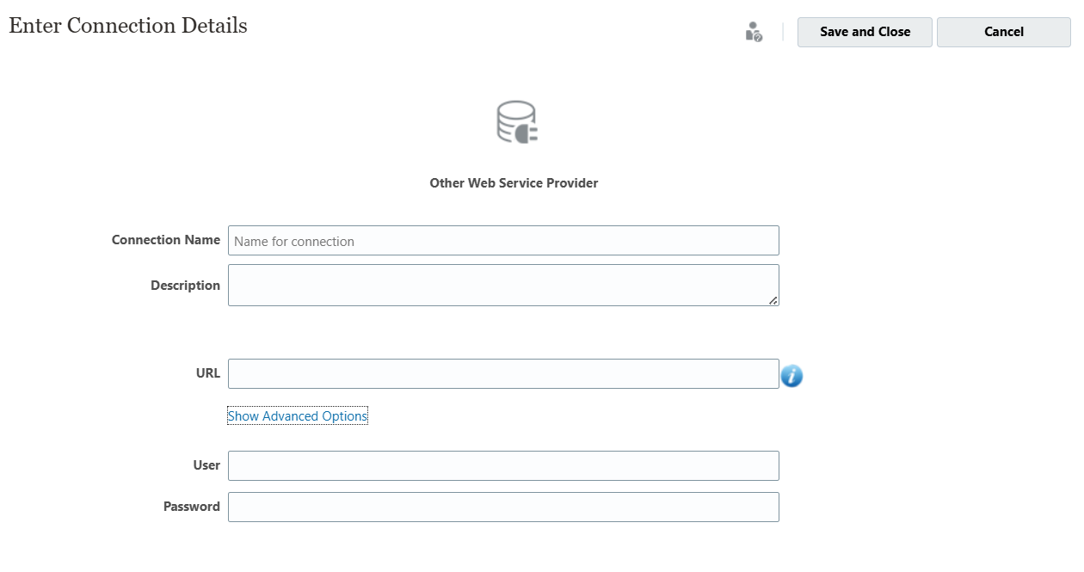
Enter the Connection details and parameters if required in Advanced Options.
Connection Name : Name your connection appropriately
URL: Provide the API
- U can provide the API with endpoint for specific requirements
- Or give the API without endpoints
Provide Credentials
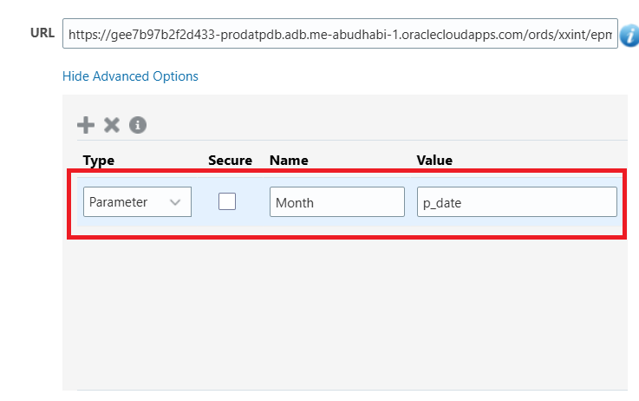
Use Advanced Options to provide parameters.
Connecting to Api and Fetching the Data.
Code 1:
/*RTPS: {Month} */

def pDate = rtps.Month.EnteredValue
HttpResponse<String>jsonResponse=operation.application.getConnection("TestRestAPI").get().queryParam("p_date",pDate).asString()
def body = jsonResponse.getBody().toString()
def oj = new groovy.json.JsonSlurper().parseText(body)
def object = oj as Map
println object.getClass()
/*def ls=object.keySet()
println ls*/
List<Map> details=object.get('data') as List
/*int si = details.size()
println si*/
csvWriter("EmpDetails.csv").withCloseable { out ->
// ── HEADER ROW ────────────────────────────────────
out.writeNext(["employee_number", "employee_name", "position"] as String[])
// ── DATA ROWS ─────────────────────────────────────
details.each { Map entry ->
def empNumber = entry['employee_number']?.toString() ?: ""
def empName = entry['employee_name']?.toString() ?: ""
def position = entry['position']?.toString() ?: ""
out.writeNext([empNumber, empName, position] as String[])
}
}
Output: This Code will generate a CSV file and Store it in local inbox/Outbox Explorer
Sending Email With Attachment:
Code
def toEmail = "jameervali.dudekula@nalsoft.net"
def subject = "File Email"
def cont = "This is a system generated mail using APIs"
def attach = "EmpDetails.csv" // ✅ prefix required
def connection = "CurrentApp"

// ✅ variable name matches what's defined above
def requestBody = "to=${toEmail}" +
"&subject=${subject}" +
"&body=${cont}" +
"&attachments=${attach}" // ✅ 'attach' not 'attachment'

println "Request Body : ${requestBody}"

HttpResponse<String> response = operation.application
.getConnection(connection)
.post('/interop/rest/v1/services/sendmail')
.header('Content-Type', 'application/x-www-form-urlencoded')
.body(requestBody)
.asString()

println response.Body

final int IN_PROGRESS = -1

ReadContext ctx = JsonPath.parse(response.body)
String jobId = ctx.read('$.links[1].href').toString().split('/').last()
int jobStatus = ctx.read('$.status')

println "Job ID : ${jobId}"
println "Initial status: ${jobStatus}"

long delay = 50
while (jobStatus == IN_PROGRESS) {
sleep(delay)
delay = Math.min(2000, delay * 2) // exponential backoff, max 2s

HttpResponse<String> pollResponse = operation.application
.getConnection(connection)
.get("/interop/rest/v1/services/jobs/${jobId}")
.asString()

jobStatus = JsonPath.parse(pollResponse.body).read('$.status') as int
println "Polling... status: ${jobStatus}"
}
println jobStatus == 0 ? "✅ Email Sent Successfully!" : "❌ Email Failed. Status: ${jobStatus}"

Output:
